But we'll now take a look at watchpoints so first of all, click on the watchpoints button and you'll see that the screen changes so that we see the program code in the top section and then we see a watchpoint table in the lower part of the screen.

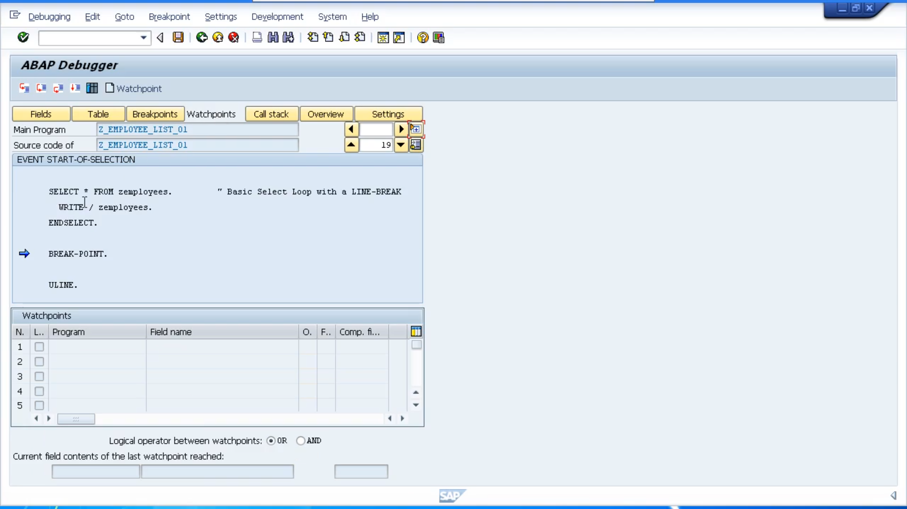

Now we have previously discussed break points. And you will no doubt understand how useful break points are when debugging your program. But there are often times when break points are not the ideal tool to use to pause our code so we can interrogate the contents of individual fields and internal tables and to analyze the logic of our program.

Imagine our program was processing a table containing 1,000 records. And we wanted to debug the logic in our program. But only when a certain condition occurs. And this condition is dependent on the data held within the records we're processing by using break points. We would have to debug each record individually, which could take us a long, long time. And this is where watchpoints come in.

We can actually tell our program to stop, just like a break point, but instead at a specific line of code, we can tell it to stop based on the value in a field. So, we, now, an example. If a specific value we wanted to analyze only occurred on the 200th record within our large table, setting a watchpoint would allow us to skip the first 199 records and focusing specifically on that 200th record that is of interest. So, let's take a look at how we can create a watchpoint.

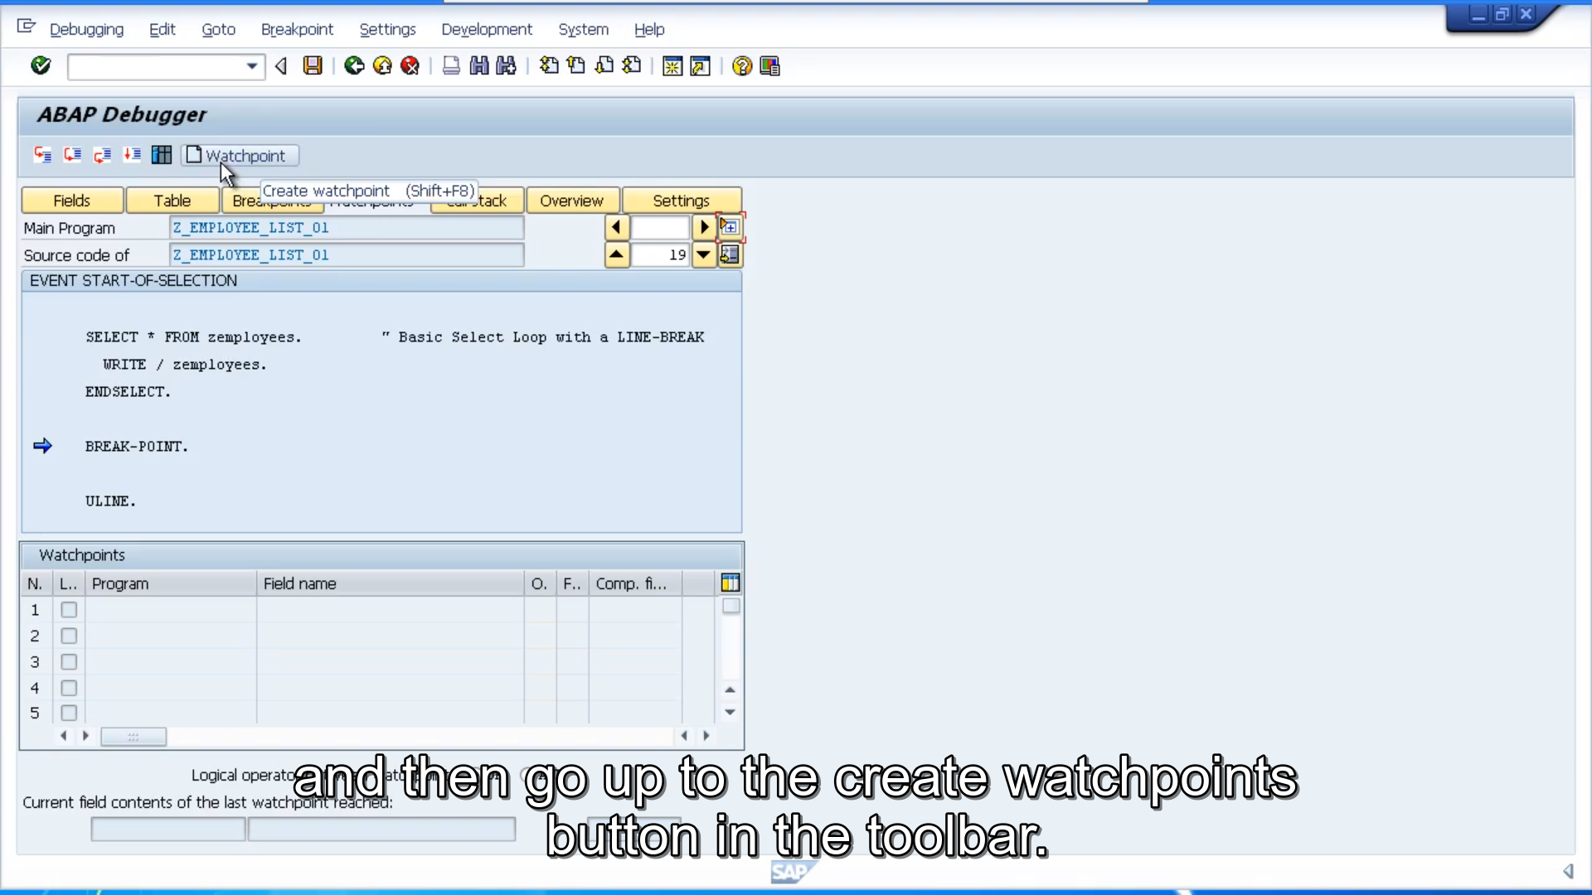First thing we need to do is make sure you've pressed the watchpoints button, and then go up to the create watchpoints button in the toolbar. You can also use the Shift F8 shortcut keys.

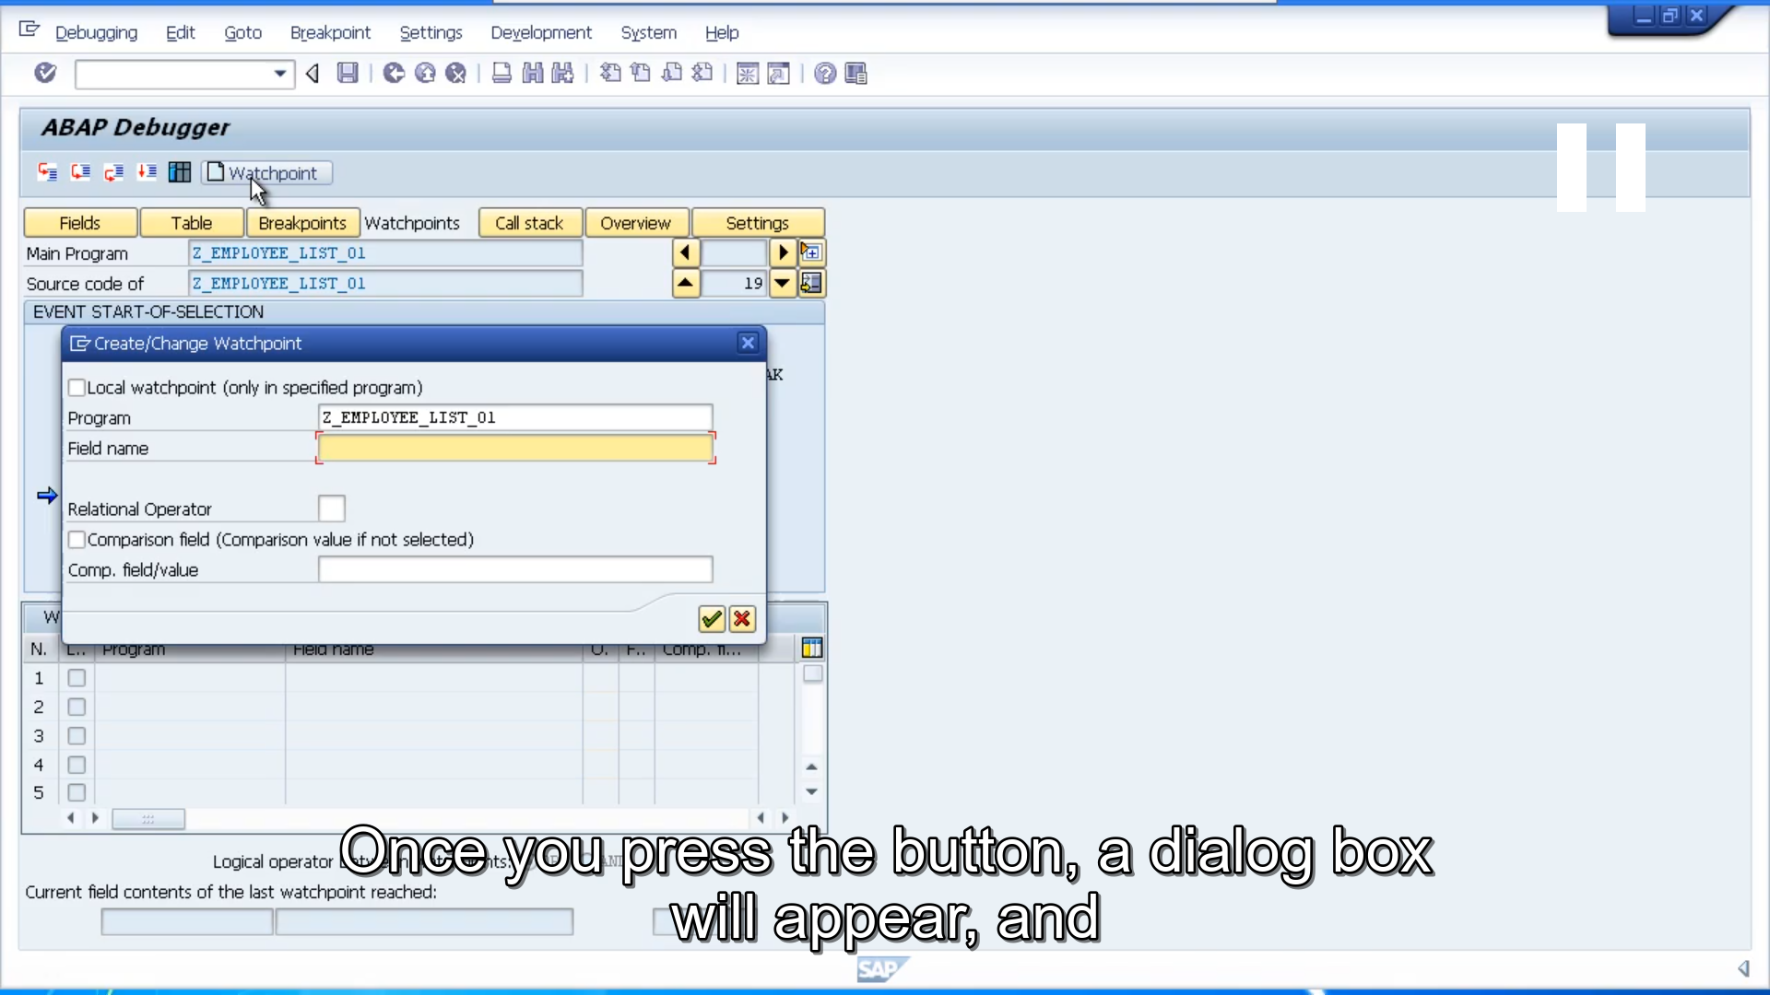

Once you press the button, a dialog box will appear, and it will already have the program name filled in. And what you need to fill in is the field name that you want to watch. So, in our example, let's say we want to watch the employee surname. So, the first thing I need to do is key in the table name which is Z employees. Followed by a dash and then surname. We then need to set the relational operator. In our case we'll look for surname equalling a value of Mills. So, we would use the equal relational operator.

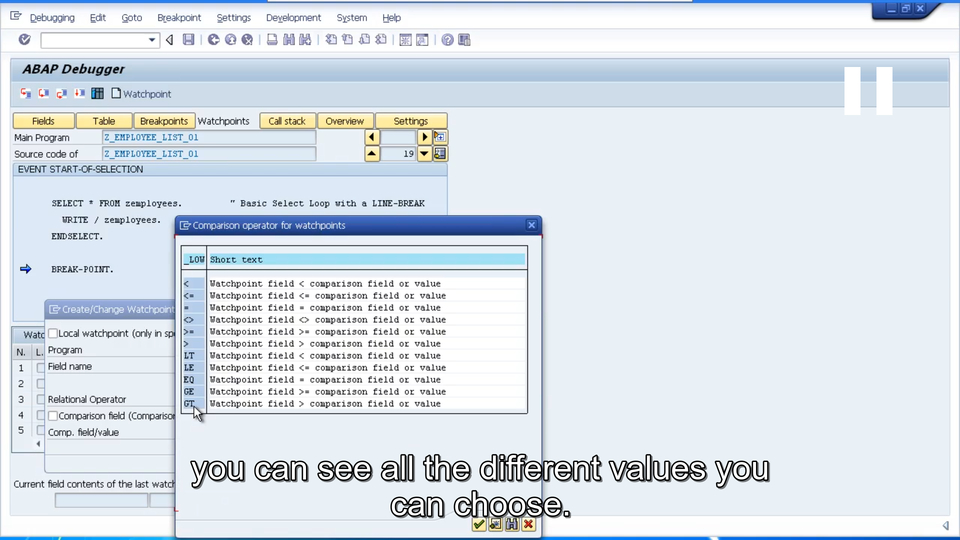

I'll show you the drop-down box just so you can see all the different values you can choose. We'll chose the equal’s sign. And then I'll key in the bottom field the value of Mills now one note here is you don't have to use a specific value here. You can get your watchpoint to compare your field against another field in your program. All you need to do is click this comparison field and fill in the field name. But in our case, we'll just stick with the specific value of Mills. Once you've done this, click the create stroke change watchpoint button.

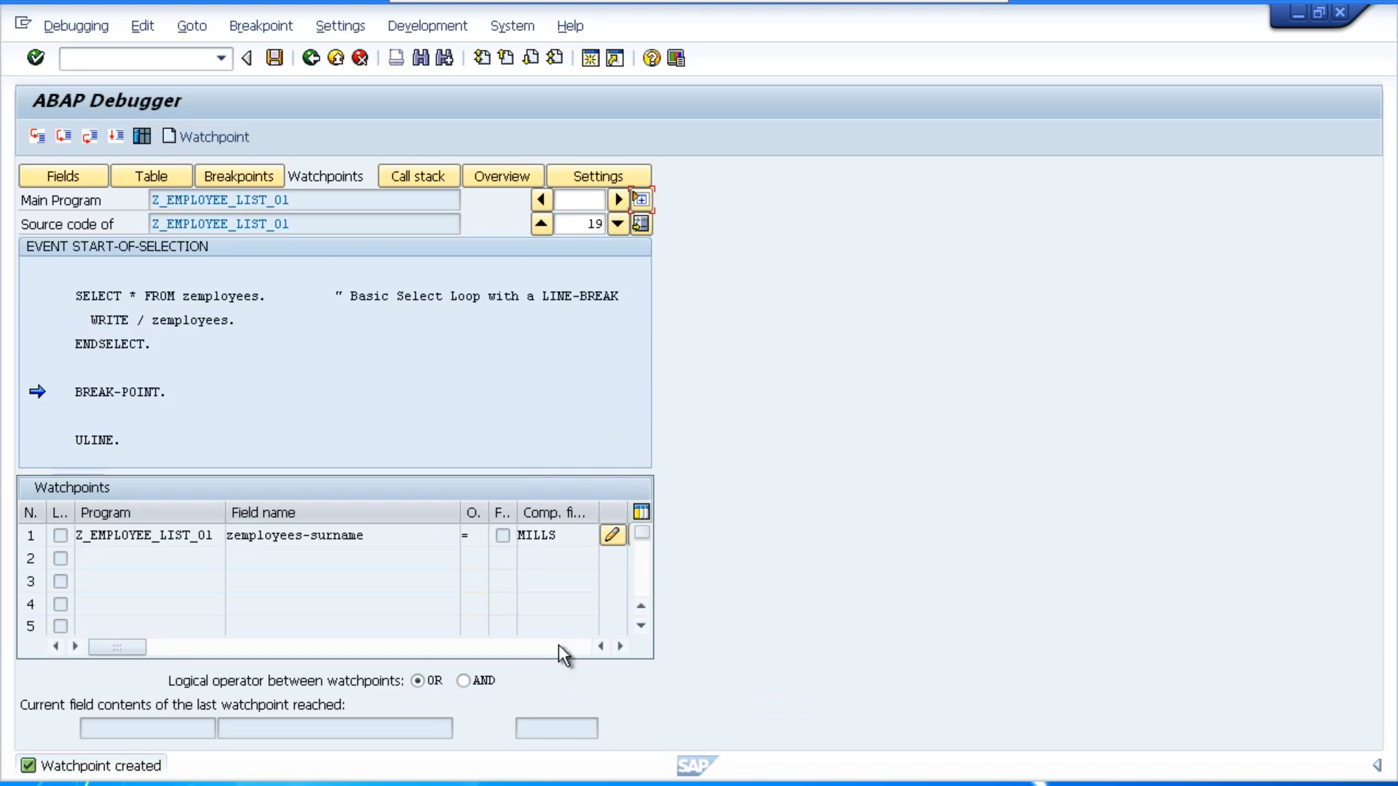

And then you'll see your entry has been added into the list at the bottom of the screen. Now just keep an eye on this section at the bottom down here. Where it says current field contents of the last watchpoint reached. It's currently empty, but now when we execute our program, the program should then pause when the employee surname contains a value of Mills. So just before we execute the code, we'll take a quick look at the output to see whereabouts in the processing we are up to. And we can see the second site loop has just completed.

So, the next select statement should select the record, Stephen Brown. It'll then need to cycle through additional records until it gets to the fifth record of Alex Mills, and that's where the program should stop. So, let's step back and we'll press the F8 button to continue. And now you can see the program has paused.

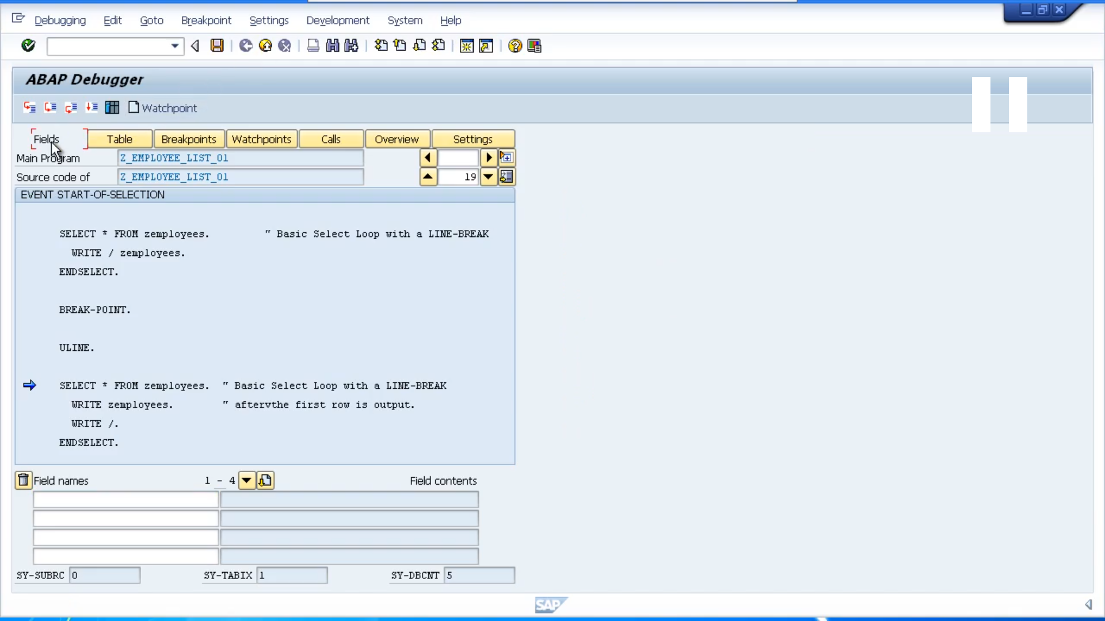

The blue arrow is pointing to our next select statement, and if we have looked at the outputs, it should have output four records and paused before it's outputting the fifth record which should contain the surname Mills. And that's exactly what it's done. So, this is the start of the next select loop we can see its output four records, the next one would be Haleys Mills but it is paused and just to double check that in the fields mode let's key in the actual field and have a look at the contents so key in Z employees dash surname press enter and there we can see the actual value at the moment in memory.

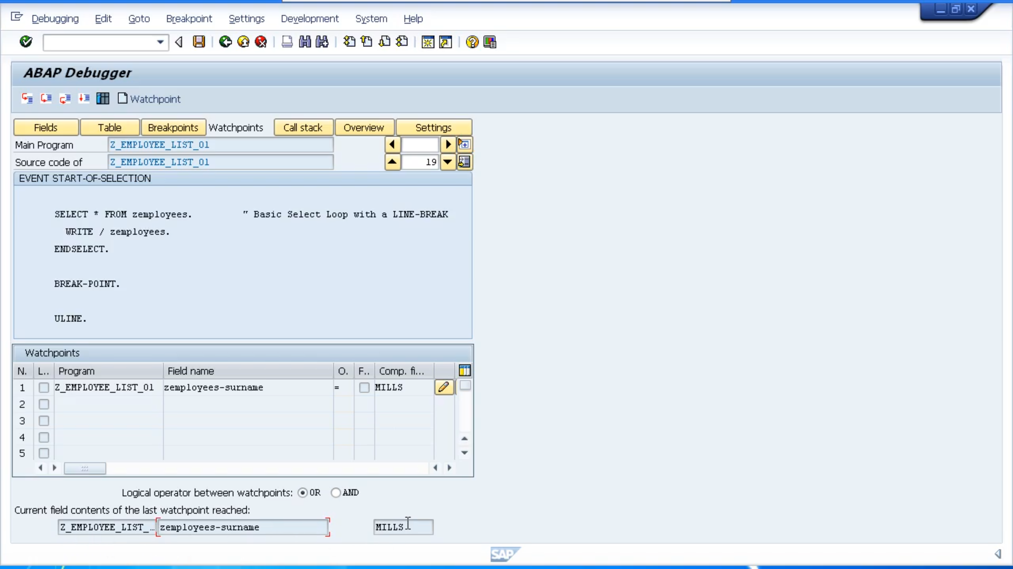

Does equal Mills and also if you click the watch point button again, you'll see those fields right down at the bottom of the screen actually contain the values we are looking for. Watchpoints are a real handy tool that can save you a lot of time debugging your code. When your test data contains many, many records.